**Title:** Functional trade-offs and microclimatic drivers of seed oil traits in alpine environments

**Authors:** Clara Espinosa del Alba1,2, Andrea Mondoni3, Silvia Baizán4, Eduardo Fernández-Pascual1,2 & Borja Jiménez-Alfaro1,2.

**Affiliations:**

1-Biodiversity Research Institute (IMIB), University of Oviedo-CSIC-Principality of Asturias, Mieres, Asturias, 33600 Spain.

2-Department of Organismal and Systems Biology, University of Oviedo, Oviedo, Asturias, 33071 Spain

3-Dipartimento di Scienze della Terra e dell’Ambiente, University of Pavia, 27100 Pavia, Italy.

4-Servicio Regional de Investigación y Desarrollo Agroalimentario (SERIDA), Carretera AS-267, PK. 19, 33300 - Villaviciosa (Asturias), Spain

**Correspondence author**: Clara Espinosa del Alba. Email: clara.esdal@hotmail.es

**ORCID**

Clara Espinosa del Alba. https://orcid.org/0000-0001-8634-5808

Andrea Mondoni. <https://orcid.org/0000-0002-4605-6304>

Silvia Baizán. [https://orcid.org/0000-0003-3462-9432](https://urldefense.com/v3/__https:/orcid.org/0000-0003-3462-9432__;!!D9dNQwwGXtA!Xml2rQNvfPwkNvs0eS3TGXuVlZFuFqVAC3lLbmWnvqHuF40MJjfPGhl_28WTJ5f2hlGtilbO-rLtC_kPqjbV$)

Eduardo Fernández-Pascual. <https://orcid.org/0000-0002-4743-9577>

Borja Jiménez-Alfaro. <https://orcid.org/0000-0001-6601-9597>

**Words count**

Introduction: 1541

Material and methods: 1827

Results: 913

Discussion: 1727

Number of figures: 5 (all in color)

Numbers of Tables: 1

**Supporting information (brief legends)**

Figure S1. Regional species pool’s phylogenetic tree

Figure S2. Local alpine species pool phylogenetic tree

Table S1. Fatty acids Methyl Ester (FAME) list

Table S2. Fatty acid types descriptive statistics summary

Table S3. Optimal temperatures for species germination

Table S4. Oil data PCA detailed results

Table S5. MCMC models fixed effects results

Table S6. MCMC models random factors results

**Funding**

Agencia Española de Investigación - Spanish Research Agency (AEI/10.13039/501100011033)

Ayuntamiento de Gijón/Xixón (SV-23-GIJON-JBA)

Grant “Laboratorio de Vegetación y Biodiversidad” (IDE/2024/000720, Principality of Asturias-Sekuens-EU-FEDER).

**Data availability statement**

Raw data and R script for analysis are available in GitHub, once the manuscript is accepted the GitHub repository will be public and stored in Zenodo.

**Competing interests:** None declared

**Acknowledgements**

We are grateful to the Analysis Service Unit facilities of ICTAN for the seed oil analysis using Chromatography. We want to thank Giovanni Marchese and Francesco Cortese for their assistance in laboratory work. We also thank the Picos de Europa National for support in field sampling. This research is framed within the SEEDALP project (MCI-20-PID2019-108636GA-I00) funded by the Spanish Research Agency (AEI/10.13039/501100011033), and supported by Ayudas para Contratos Predoctorales para la Formación de Doctores del Ministerio de Ciencia e Innovación (FPI: MCI-21-PRE2020-092874); Ayuntamiento de Gijón/Xixón - Jardín Botánico Atlántico (SV-23-GIJON-JBA) and the grant “Laboratorio de Vegetación y Biodiversidad” (IDE/2024/000720, Principality of Asturias-Sekuens-EU-FEDER).

**Author contributions CREDIT**

Conceptualization: Clara Espinosa del Alba, Borja Jiménez-Alfaro; Investigation: Clara Espinosa del Alba, Silvia Baizán, Andrea Mondoni; Formal Analysis: Clara Espinosa del Alba, Andrea Mondoni; Writing – original draft: Clara Espinosa del Alba; Writing – Review & Editing: all authors; Supervision: Borja Jiménez-Alfaro, Eduardo Fernández-Pascual, Andrea Mondoni; Funding acquisition: Borja Jiménez-Alfaro.

## Summary

* Seed oil content is a crucial energy reserve in angiosperms influencing biological functions and plant fitness. However, the eco-evolutionary role of seed oil traits in ecosystems has been largely unexplored.
* Here, we study functional trade-offs and ecological drivers of seed oil traits in 47 species of an alpine flora. We analysed seed oil content and composition – the relative proportion of unsaturated and saturated fatty acids, UFA/SFA; and their relationships with seed mass, longevity, and germination timing. We also tested the response of seed oil traits to species' ecological preferences along microclimatic gradients.
* Seed oil content ranged from 1 to 38%, with a main gradient explained by UFA/SFA ratio, with little variation across elevation. Seed oil content significantly influenced seed longevity, but we didn´t find relationships with seed mass and germination. Contrary to expectations, microclimatic gradients didn´t affect seed oil content or composition. All analyses showed strong phylogenetic constraints on seed oil traits.
* Seed oil traits in alpine species don´t differ from other herbaceous species. A major trade-off between seed oil and seed longevity may explain seed persistence in alpine soils. The strong evolutionary conservatism of seed oil traits likely prevents selective responses of alpine species across elevation and microclimatic gradients.

Keywords: alpine species; altitudinal gradient; fatty acids; germination; longevity; microenvironmental gradients; seed oil composition; seed oil content.

**Translated summary (Spanish)**

• El contenido de aceite en las semillas es una reserva energética crucial en las angiospermas, que influye en las funciones biológicas y en el éxito reproductivo de la planta. Sin embargo, el papel ecológico y evolutivo del aceite de las semillas en los ecosistemas ha sido en gran parte inexplorado.

• En este estudio, analizamos los compromisos funcionales y los factores ecológicos del aceite de las semillas en 47 especies alpinas. Analizamos el contenido y la composición del aceite de las semillas – la proporción relativa de ácidos grasos insaturados (UFA) y saturados (SFA); y sus relaciones con la masa, longevidad y germinación de las semillas. También evaluamos la respuesta del aceite de las semillas a las preferencias ecológicas de las especies a lo largo de los gradientes microclimáticos.

• El contenido de aceite en las semillas varió entre un 1% y un 38%, con el gradiente principal explicado por la relación UFA/SFA, aunque con poca variación a lo largo del gradiente de altitud. El contenido de aceite influyó significativamente en la longevidad de la semilla, pero no encontramos relaciones con la masa ni con la germinación de las semillas. Opuesto a lo esperado, los gradientes microclimáticos no afectaron el contenido ni la composición del aceite de las semillas en plantas alpinas. Todos los análisis mostraron fuertes restricciones filogenéticas en los rasgos del aceite de las semillas.

• El aceite de las semillas de especies alpinas no difieren de otras especies herbáceas. Un compromiso importante entre el contenido de aceite y la longevidad de las semillas podría explicar la persistencia de las semillas en los suelos alpinos. El fuerte conservacionismo evolutivo del aceite de las semillas probablemente impide respuestas selectivas de las especies alpinas a lo largo de los gradientes de altitud y microclimáticos.

## 1. Introduction

Seeds are energy reservoirs, mainly accumulating three macromolecules: proteins, lipids and carbohydrates (Levin, 1974; Baud & Lepiniec, 2010). The quantity and quality of these reserves are directly related to plant fitness, as they influence primary regeneration functions like seed persistence in the soil seed bank via seed longevity (Hoekstra, 2005), germination timing (Linder, 2000), and seedling establishment (Graham, 2008). Seed traits related to oil content may therefore influence the regeneration of plant communities (Jiménez-Alfaro *et al.,* 2016) and related ecosystem functions (Saatkamp *et al.*, 2019). In angiosperms, the predominant reserve forms are lipids and carbohydrates, the former in the form of triglycerides (an ester of glycerol plus three fatty acids) (Harwood, 1980; Voelker & Kinney, 2001), and the latter accumulated as starch (Levin, 1974). Carbons in fatty acids, through lipid oxidation, release more than twice the energy than starch oxidation because their carbons are highly reduced (Levin, 1974; Baud & Lepiniec, 2010). Consequently, plants mainly rely on lipids (hereafter “seed oil”) for energy mobilization during germination (Harwood, 1980). In endospermic seeds, seed oil is mainly stored in the cotyledons and endosperm (Ellis, 2006) but also in the radicle and hypocotyl (Li *et al.*, 2006).

In seeds, most fatty acids range from 10 to 22 carbons in length, and the carbons may be joined by single or double bonds, referred to as saturated (SFA) and unsaturated fatty acids (UFA), respectively (Ellis, 2006). The relative proportions of unsaturated and saturated fatty acids constitute what we will refer to as “seed oil composition”. The most abundant fatty acids found in seeds are unsaturated oleic acid (18:1n-9), linoleic acid (18:2n-6), alpha-linolenic acid (18:3n-3), and saturated palmitic (16:0) and stearic (18:0) acids (Voelker & Kinney, 2001; Ellis, 2006; Baud & Lepiniec, 2010). Unsaturated and saturated fatty acids possess distinct biochemical properties (Lehninger *et al.*, 1993), influencing their functioning as an energy reserve. On a per-carbon basis, unsaturated fatty acids are more expensive to produce and yield less energy when oxidised than saturated fatty acids (Lehninger *et al.*, 1993; Linder, 2000). Moreover, unsaturated fatty acids have a higher potential for oxidative damage (Rael *et al.*, 2004), requiring antioxidant molecules to prevent damage. Hence, an optimal energy storage strategy for seeds should maximise saturated storage instead of unsaturated fatty acids (Linder, 2000). However, contrary to expectations, many species synthesise a low amount of saturated fatty acids (Linder, 2000). A potential explanation for this counter-intuitive pattern is that saturated fatty acids have a higher melting point than unsaturated fatty acids (Knothe & Dunn, 2009; Sanyal & Decocq, 2016), making energy less accessible at low temperatures. Additionally, the biochemical properties of unsaturated fatty acids increase unpalatability, serving as a defence against herbivory, and also function as anti-freezing compounds (Linder, 2000); see Fig. **1a** for a summary table.

While seed oil content is expected to be constrained by phylogeny and subject to evolutionary change (Levin, 1974), variation in oil content and oil composition exists within and among genera of the same family (Levin, 1974; Voelker & Kinney, 2001; Bretagnolle *et al.*, 2016). Seed oil traits may influence a wide range of biological functions and, as such, are crucial for plant adaptation (Levin, 1974; Sanyal & Decocq, 2016), especially when regeneration stages come into play. It is known that seed energy and oil content are positively correlated (Levin, 1974; Bretagnolle *et al.*, 2016). Such a relationship suggests that oil synthesis is energetically costly and could be advantageous only for small seeds, which can store more energy in a smaller volume (Bretagnolle *et al.*, 2016). Large seeds generally store less oil than small seeds; however, a tiny oily seed can release as much energy as a larger, starchy seed (Bretagnolle *et al.*, 2016). In the literature, there is a consensus that seed mass and oil content are negatively correlated, with seed oil content contributing up to 60% of seed mass weight (Ellis, 2006; Theodoulou & Eastmond, 2012). In concordance with this trade-off, there could be indirect correlations between oil content and other seed traits and functions like dispersal (Westoby *et al.*, 1996) and germination rates (Bu *et al.*, 2007). In other words, selection could act simultaneously on multiple seed traits (Sanyal & Decocq, 2016), revealing other ecological trade-offs. For example, previous studies have claimed that seed oil content influences seed longevity (Hoekstra, 2005), meaning the ability of seeds to remain viable over specific storage periods, which partially determines the capacity of seeds to persist in the soil seed bank. Secondary lipid oxidation metabolites, needed for energy release, can cause detrimental effects on other macromolecules (Graham, 2008). Remarkably, the oxidation of unsaturated fatty acids contributes significantly to producing free radicals and subsequent attacks by these radicals (Harman & Mattick, 1976). To prevent deleterious effects, oily seeds also store antioxidants, and studies show a positive correlation between antioxidant levels and the relative proportion of unsaturated fatty acids (Sattler *et al.*, 2004). Accordingly, previous studies have found oily seeds to be more prone to ageing (Nagel & Börner, 2010; Neto *et al.*, 2019), and detailed studies, including oil composition, have also shown that a higher proportion of unsaturated fatty acids is associated with shorter longevity (Hoekstra, 2005). Thus, not only oil content but also oil composition affects the storage behaviour of seeds (Volk *et al.*, 2006). Further investigations on the effects of seed oil content and composition on longevity are therefore desirable (Pritchard & Dickie, 2003) but are lacking for most wild species.

Another key process in seed regeneration is germination, a complex and irreversible process which requires the use of the energy stored in the seed (Nonogaki *et al.*, 2010). It is reasonable to think that the greater the energy reserve, i.e. oil content, the higher and faster germination (Gardarin *et al.*, 2011), especially in conditions of higher competition (Levin, 1974). It has also been reported that due to the different fatty acid melting points, under colder temperatures, seeds with a higher proportion of unsaturated fatty acids can germinate earlier (Linder, 2000). These results suggest that seed oil content and composition may impact the regeneration niche of species along ecological gradients. In a pioneering study on wild species, Levin (1974) found significant seed oil content variations depending on habitat type (oil content increased in woodlands) and life form (lower oil in herbs than in shrubs and trees) but no geographical differences, except within herbs where subtropical herbs showed higher oil values than temperate and tropical herbs. However, a more recent study found a general latitudinal gradient, with higher seed oil content in tropical plants compared to temperate plants (Sanyal & Decocq, 2016). In the tropics, seeds need higher energy to germinate fast and survive the first life stages with high competition for light (Levin, 1974). The same study found relevant gradients in oil composition, with saturated fatty acids decreasing with increasing latitude (Sanyal & Decocq, 2016), in concordance with previous studies (Linder, 2000). Higher growing temperatures have been correlated with higher oil content in several cultivars (Piper & Boote, 1999) and higher saturated fatty acid accumulation (Sanyal & Linder, 2013). Additionally, the different fatty acid melting points can give a complementary explanation. At higher latitudes (cooler temperatures), seeds with higher unsaturated fatty acids proportions (and a lower melting point) can access the energy stored earlier, providing a competitive advantage (Linder, 2000). At lower latitudes (higher temperatures), seeds do not have a temperature limitation to access higher saturated fatty acids energy resources with higher melting points (Sanyal & Decocq, 2016). Consequently, seed oil content and composition seem to be under strong selection by temperature at both micro- and macro-ecological levels (Sanyal & Linder, 2013; Sanyal & Decocq, 2016).

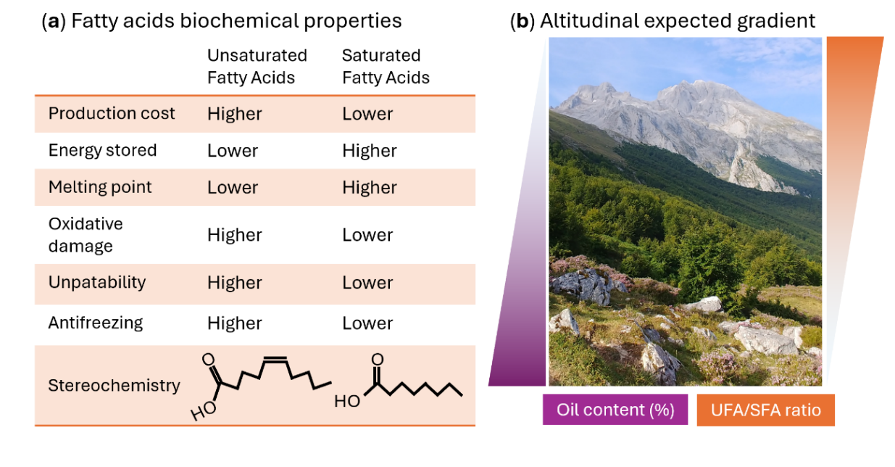

Figure 1. (**a**) Fatty acid biochemical properties; (**b**) Altitudinal oil content and unsaturated UFA/SFA ratio (Unsaturated Fatty Acids /Saturated Fatty Acids) patterns expected in our study.

In this study, we investigate seed oil traits in a regional alpine flora. Alpine ecosystems are unique laboratories to explore seed oil traits because they are subjected to strong ecological filters towards similar life forms (Körner, 2021), but at the same time, support high evolutionary diversity (Rahbek *et al.*, 2019) and variation across microclimatic gradients (Scherrer & Körner, 2011, Jiménez-Alfaro *et al.*, 2024). In temperate regions, alpine species are generally known for having average-sized seeds (Körner, 2021), short longevity (Mondoni *et al.*, 2011), and delayed germination phenology (Espinosa del Alba *et al.*, 2024) due to physiological dormancy (Fernández-Pascual *et al.*, 2021). Since alpine plants have adapted to multiple reproductive strategies (through different flowering, seed and clonal traits), they might also show selective patterns of seed oil traits in response to elevation and microclimatic snow gradients. However, the patterns and drivers of seed oil traits have been generally unexplored since the seminal studies of Levin (1974) and Linder (2000), with a general lack of information about the functional trade-offs or ecological drivers influencing seed oil traits in alpine ecosystems. To address this limitation, our first aim is to characterize seed oil content and composition in an alpine flora, and their relationships with elevation and seed mass (Figure 1). Our second aim is to investigate functional trade-offs between seed oil traits and other traits related to seed regeneration, namely seed mass, seed longevity and germination timing. Our third aim is to test the role of microclimatic drivers related to temperature and snow cover in explaining variation of seed oil content and composition. Our expectations for the second and third aims (Table 1) were elaborated from existing literature as indicated above.

Table 1. Expected predictions for functional tradeoffs and ecological drivers influencing seed oil content and composition (Ratio between Unsaturated and Saturated fat acids, UFA/SFA) in alpine plants. P50: time for viability to drop to 50%; EHS (Environmental Heat Sum) calculated as the amount of degrees Celsius (°C) accumulated for each species until reaching 50% germination.

|  |  |  |  |
| --- | --- | --- | --- |
|  | | Oil content | Ratio UFA/SFA |
| Functional trade-offs | | | |
|  | Seed mass | Decreasing seed mass with increasing oil content | Decreasing seed mass with increasing ratio |
| Seed longevity (p50) | Decreasing p50 with increasing oil content | Decreasing p50 with increasing ratio |
| Germination timing (EHS) | Decreasing EHS with increasing oil content | Decreasing EHS with increasing ratio |
| Ecological drivers | | | |
|  | Growing Degree Days (GDD) | Increasing oil content with increasing GDD | Decreasing ratio with increasing GDD |
| Freezing Degree Days (FDD) | Decreasing oil content with increasing FDD | Increasing ratio with increasing FDD |
| Snow Days (Snow) | Decreasing oil content with increasing snow | Increasing ratio with increasing Snow |

## 2. Materials and Methods

### Study system

We focused on herbaceous alpine species from grassland communities in the Cantabrian Mountains (north-western Spain), a transitional mountain system between southern Europe's temperate and Mediterranean regions (García-Gutiérrez *et al.*, 2018). These grassland communities are continuously distributed along the mountain range, occupying areas above the treeline and around mountaintops between 1580 and 2600 m a.s.l (González Le Barbier *et al.*, 2025). Grassland communities are predominantly dominated by Poaceae and Cyperaceae, and the main life forms are hemicryptophytes and dwarf chamaephytes. Climatic conditions follow a north-south temperature and precipitation gradient, with colder and wetter conditions on northern slopes compared to warmer and drier conditions on southern slopes. Mean annual temperatures in the study area range from 2.5 to 4.5 °C, and mean annual precipitation ranges from 800 to 1800 mm (values extracted from Spanish Meteorological Agency, Chazarra Bernabé *et al.*, 2018). We established eight sampling sites in the alpine grassland zone, four on the northern slopes and four on the southern slopes of the Cantabrian Mountains, ensuring representation of the flora from the two biogeographical regions. We collected floristic and community composition data for all vascular plants at each sampling site and classified species as strict alpine or generalist according to their altitudinal distribution in the study region. We identified plant specialists as those significantly associated with alpine grasslands, using the Indicator Values (IndVal) in the indicspecies R package (De Cáceres & Legendre, 2009). The calculations were based on 12,000 vegetation plots of grasslands stored in the SIVIM database (www.sivim.org) for the ecoregion in which our system occurs (WWF Cantabrian Mixed Forest ecoregion). Seed collection permits were granted for the sampling sites inside Picos de Europa National Park: expedient numbers CO/09/203/2021 and CO/09/192/2023.

### Seed oil and seed mass

In a preliminary exploratory analysis, we tested a destructive method to calculate seed oil content and composition for three seed lots from five species and different taxonomic families. Since we did not find significant differences within the seed lots and the coefficient of variation was minimal, we focused our seed collections on a single sample per species. Out of the 119 initially recorded species, we collected enough material for 47 species (19 plant families), with at least 200 mg of dry seeds per sample. The determination of fatty acid composition in the extracted oils was performed at the USTA-CSIC laboratory using gas chromatography (GC) coupled to a flame ionization detector (FID) (Agilent Technologies, 7820A, Santa Clara, CA, USA), following the internal derivatization procedure to methyl esters proposed by Lee *et al.* (2012, section 2.2.4). Chromatograms were recorded and analysed using Agilent EZChrom Elite software, potentially detecting up to 45 fatty acids (Supplementary Table S1). As a result, we obtained the value of the oil content on a dry-weight basis and the percentage of each fatty acids type relative to the total oil content. The analysis identified 26 fatty acid types in the studied species (see supplementary Table S2). This data set was used to conduct the local alpine species analysis of the variation in seed oil content and composition and seed mass data for the 47 species, measured by averaging the weight of five replicates of 50 dry seeds. Oil analyses and measurements were done in three batches, corresponding with seed availability after each year's collection campaign. We collected fully mature seeds, following the ENSCONET (2009) protocol, and applied a consistent methodology for all experiments. Nevertheless, to ensure comparability, we conducted a preliminary analysis to test potential differences in oil analysis between years (data not shown). Since we did not find significant differences between years, we are confident that our dataset is comparable and appropriate for the proposed analysis.

To contextualize our study at the regional level and for comparison with non-alpine species, we retrieved seed oil and seed mass information for another 33 species native to Europe, congeneric with the species we collected, from the Seed Information Database (SID) (SER *et al.*, 2023) and classified as either generalist or strict lowland species. In addition to our own seed oil data, we used these data to test potential effects of species altitudinal distribution, obtaining oil content and seed mass data for 80 species (29 strict alpines, 31 generalists and 20 strict lowlands) from 19 plant families and 12 orders.

### Seed germination and longevity

To estimate the germination timing, we used the Environmental Heat Sum trait (EHS) as a surrogate of germination timing, calculated as the amount of degrees Celsius (°C) accumulated for each species until reaching 50% germination, obtained from a previous phenology germination experiment conducted in the same study region (Espinosa del Alba *et al.*, 2024) and available for 34 of our study species. Using EHS instead of time or speed values allows to standardize germination timing metrics independently of incubation temperatures. This metric is also a good surrogate of germination strategies of alpine plants that allows to differentiate ecological preferences in alpine habitats (Espinosa del Alba *et al.*, 2024).

Seed longevity was experimentally calculated for 33 species in the laboratory using a standard comparative longevity protocol (Probert, Daws and Hay, 2009; Davies *et al.*, 2016) optimised for short-lived species (Davies *et al.*, 2016) and successfully applied to alpine species by Mondoni *et* *al.*, (2011). The artificially accelerated ageing protocol allows the measurement of the p50 value (amount of time for seed viability to drop to 50%). Before the start of the ageing protocol, all species were tested to ensure germination above 85% (see specific germination conditions below) and species of Cistaceae were scarified with sandpaper to break physical dormancy. Seed samples (210 seeds/ species) were first rehydrated to 47% relative humidity (RH) at 20°C for five days in a non-saturated LiCl solution (Hay *et al.*, 2008) in crystal Petri dishes and kept in a 300 x 300 x 130 mm sealed electric enclosure box (Ensto UK Ltd, Southampton, UK) before moving the Petri dishes into the ageing conditions. The ageing conditions comprised a temperature of 45°C, 60% RH and darkness. Subsamples of 42 seeds per species were withdrawn after 2, 10, 15 and 30 days in ageing conditions and subsequently sown in Petri dishes with 1% agar with GA3 (250 mg/L) (Davies *et al.*, 2015). Germination conditions for the species were set with a 12/12h photoperiod and two alternating temperatures, depending on species optimal germination conditions, at 22-12°C or 15/5°C (see supplementary Table S3). A special procedure was followed for *Saxifraga oppositifolia*, which requires a cold stratification period (5°C in darkness for 30 days) before moving it to germination chambers (Aralab climatic chamber Fitoclima S600 PL, equipped with 4 led modules 11W 350mA). Longevity experiments were performed in two batches, corresponding with the seed availability after each year's collection campaign, with the same protocol, and preliminary analysis showed no significant differences between experimental batches (data not shown). After sowing, seeds were checked once a week for four weeks. Germination was scored when there was a visible root (>1.5 mm) and then removed from the Petri dishes. Ungerminated seeds at the end of the test were cut-tested under the binocular stereoscope to assess the embryo's state visually. We considered seeds with white and firm embryos viable, i.e. potentially germinable (Baskin & Baskin, 2014) and removed empty or infected seeds from further analysis.

Probit analysis was carried out on the data using GenStat Release 11.1 (VSN International Ltd, Oxford, UK) to estimate the time for viability to fall to 50% (p50) by fitting the viability equation (Ellis & Roberts, 1980):

*v = Ki – (p/σ)*

where v is the viability (in normal equivalent deviates, NED) of the seed lot after p days in storage, Ki is the initial viability (NED) of the seed lot, and *σ* is the time (d) for viability to fall by 1 NED (i.e. the standard deviation of the normal distribution of seed deaths over time).

### Species´ microclimatic preferences

We established 20 plots (1 m²) per site in a parallel field experiment (Jiménez-Alfaro *et al.*, 2024) where we recorded all vascular species and buried a temperature datalogger at a depth of 5 cm (Thermochron, iButton, Newbury, UK; accuracy: ± 0.5 °C from -10 °C to +65 °C, resolution: 0.5 °C, records every four hours), recording temperatures over 11 months. From the microenvironmental data recorded, we calculated three bioclimatic indices per plot following Jiménez-Alfaro *et al.*, (2024): (1) Growing Degree Days (GDD) as the sum of daily mean temperatures for days in which the soil mean temperature at five cm deep was above 5 °C (Körner, 2021); (2) Freezing Degree Days (FDD) as the sum of daily mean temperatures for days in which the mean temperature was below 0 °C (Choler, 2018); and (3) days with snow cover, based on the period in which the daily maximum temperatures were < 0.5 ºC and the minimum temperatures were > -0.5 °C (Zhang *et al.*, 2005). Then, we used the bioclimatic indices to calculate the species' microclimatic preferences, averaging the climatic variables of the plots where the species was present and weighting them by their coverage (only considering those plots where the species had more than 10% relative coverage), assuming species would have more coverage in those plots with climatic conditions closer to their local ecological optimum.

### Statistical analysis

We analyzed the seed trait data by fitting Markov Chain Monte Carlo generalized linear mixed models (MCMCglmm) with Bayesian estimation using the R package MCMCGLMM (Hadfield, 2010). To analyze functional trade-offs, we investigated how seed oil content and composition may explain other seed biological traits (seed mass, longevity and germination timing). Thus, oil traits were used as an explanatory variable. We applied a log transformation to seed mass and EHS to meet the normal distribution of the data, and model assumptions were visually checked and fulfilled. To analyze ecological drivers (altitudinal distribution and microclimatic gradients, i.e. GDD, FDD and Snow), we investigated how seed oil and composition are regulated by microclimatic gradients across local snow-related factors. Thus, oil traits were used as the response variable, both log-transformed. We used weakly informative priors in all models, with parameter-expanded priors for the random effects. Each model was run for 1,000,000 iterations, with an initial burn of 100,000 and a thinning interval of 100. We calculated mean parameter estimates and 95% credible intervals (CI) from the resulting posterior distributions. Phylogeny was included as a random factor using a reconstructed tree (Supporting information Fig. S1 and Fig. S2 for regional and alpine species pool, respectively), created with V.PHYLOMAKER R package (Jin & Qian, 2019) using phylosignal and phylobase R packages (Keck *et al.*, 2016; R Hackaton et *al*., 2024). To work with the phylogeny and calculate the phylogenetic signal (lambda), we used the ape (Paradis & Schliep, 2019) and phylosignal packages (Keck *et al.*, 2016). To assess the significance of the models, we use the posterior mean from posterior probabilities and the credible intervals (CI). The posterior mean is an analogue of model effect sizes, and when the CI values do not overlap with 0, there is a significant effect of the explanatory variable.

## 3. Results

### Seed oil content and oil composition characterization

Within our local alpine species pool (n=47), oil content varies from 1.2% in *Avenella flexuosa* (Poaceae) to 34.2% in *Jasione cavanillesii* (Campanulaceae) (Fig. **2a**). The most abundant fatty acids in alpine seeds were the unsaturated linoleic acid (C18:2n-6c, 42.4%±2.4, mean ± se), oleic acid (C18:1n-9c, 22.6%±1.9), and alpha-linolenic acid (C18:3n3, 15.1%±2.7); as well as saturated palmitic (C16:0, 10.8%±0.8) (details in supplementary Table S2). These four make up 94.8% of seed oil content (se=23). Additionally, in our data set, erucic acid (C22:1n9) had high values only in Brassicaceae and gamma-linolenic acid (C18:3n6) in some Caryophyllaceae (Fig. **2b**). The mean frequency of saturated fatty acids is 14.2%±0.95, and the mean ratio between unsaturated and saturated fatty acids is 7.2 (se=0.5), ranging from 1.3 in *A. flexuosa* (Poaceae) up to 20.1 in *Iberis carnosa* (Brassicaceae). Poaceae, Salicaceae, and Cistaceae generally had higher proportion of saturated fatty acids, while Brassicaceae and Lamiaceae were characterized by higher unsaturated fatty acids proportion (Fig. **2c**).

We conducted a Principal Component Analysis using fatty acid values with >3% relative proportion and correlations below 0.7 to reduce dimensionality (Fig. **2d,e**). The UFA/SFA ratio contributed the most to PC1 (26.4%) followed by palmitic acid (C16:0, 18.6%), while eicosenoic acid (C20:1n9) and erucic acid (C22:1n9) mainly contributed to PC2 (21.9% and 16.3%, respectively). Additionally, PCA revealed that the oil content percentage is not correlated with any specific fatty acid (details in supplementary Table S4).

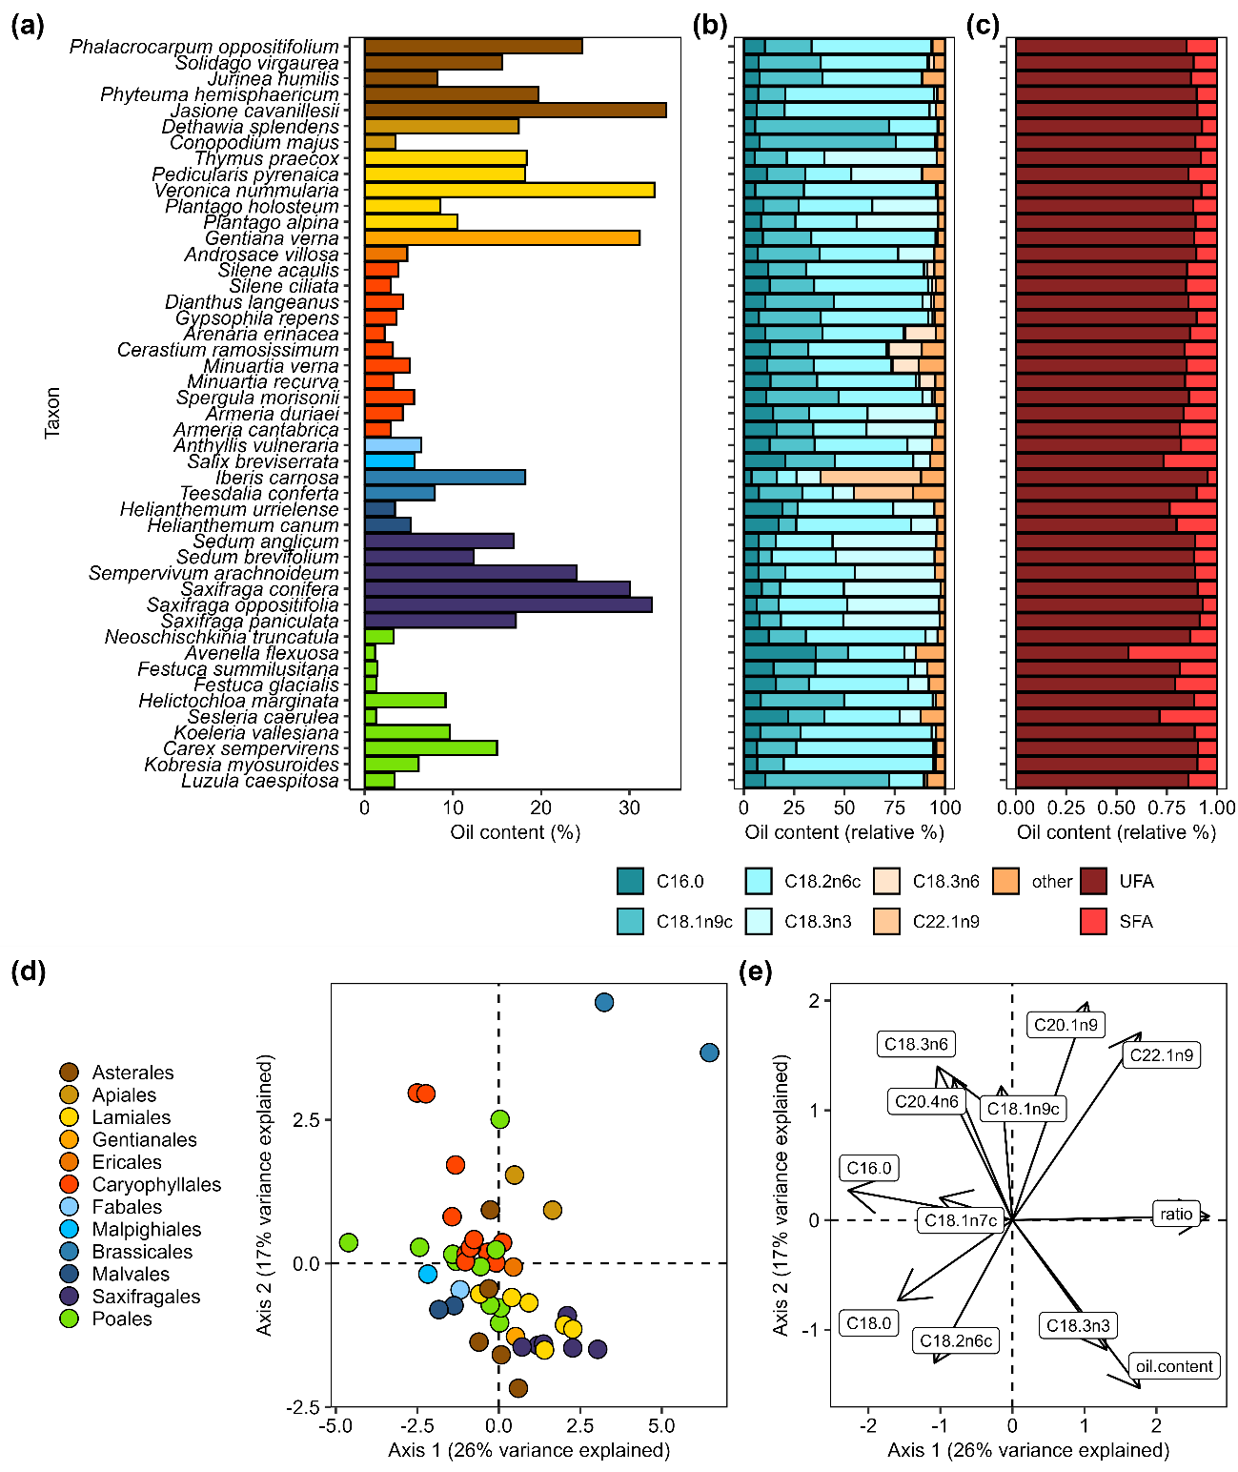

Figure 2. Seed oil content and composition in 47 alpine species from northwestern Spain. (**a**) Oil content (%) per species, colours representing orders as panel D. (**b**) Seed oil composition of fatty acids with more than 10% relative proportion on average across species. (**c**) Seed oil composition per species with fatty acids divided between Unsaturated Fatty Acids (UFA) and Saturated Fatty Acids (SFA). (**d**) PCA with species as points and (**e**) variables directions and contributions.

In our regional dataset with 80 species (Fig. **3a**), we found no significant differences in seed oil content between altitudinal distribution, i.e. strict alpine, generalist and strict lowland species (model details in supplementary Table S5), although the relationship was significantly modulated by phylogeny (posterior mean= 0.86, CI: [0.74|0.97], random factors model details in supplementary Table S6). Similarly to the patterns found in the local alpine species, oil content values ranged from 1.19% to 38%, with a mean value of 11.5%. Additionally, we found no significant correlation between seed mass (mg) and oil content (%) (posterior mean=-0.02, CI: [-0.06|0.01]); again, the relationship between both variables was significantly modulated by phylogeny (posterior mean=0.73, CI: [0.5|0.93]). We observed a considerable variation of seed oil content in smaller seeds, while variation was reduced with increasing seed mass (Fig. **3b**). Seed mass values ranged from 0.64 mg to 335 mg, with a mean value of 51 mg. When we calculated the phylogenetic signal of both traits, lambda values were 0.77 and 0.21 for seed oil content and seed mass, respectively, and significant only in seed oil content (p-value = 0.001).

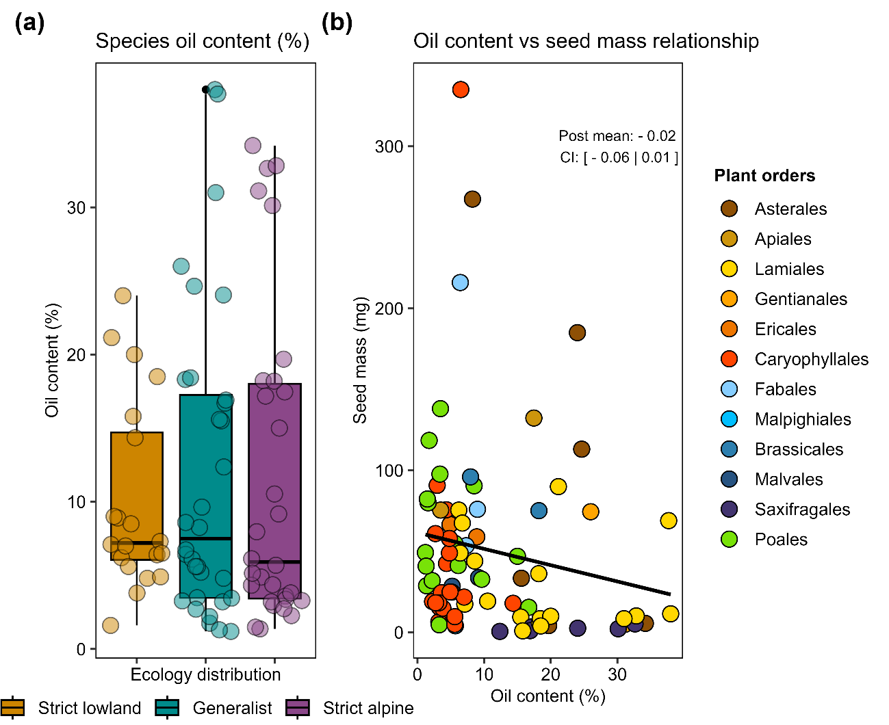

Figure 3. Regional oil content patterns (n=80 species). (**a**) Seed oil content (%) between regional altitudinal distribution showed by different colours. (**b**) Seed oil content (%) and seed mass (mg) non-significant relationship (from MCMC-GLMMs models with gaussian family) showed by posterior mean (post. mean) and credible intervals (CI); if CI values do not overlap with 0, they indicate a significant relationship.

### Functional trade-offs

Seed mass of our target alpine species ranged from 0.6 mg (*Sedum brevifolium*) to 268 mg (*Jurinea humilis*), with a mean of 45.4 mg (se=7.84). Although we observed a general trend of decreasing seed mass with a higher proportion of seed oil content, the relationship was not significant (posterior mean=-0.02, CI: [-0.06|0.02], Fig. **4a**, left panel). Seed oil composition, calculated as the UFA/SFA ratio, also did not significantly correlate with seed mass (posterior mean=-0.01, CI: [-0.11|0.09], Fig. **4a,** right panel). However, in both cases, the relationship between variables was significantly modulated by phylogeny (posterior mean=0.94, CI: [0.84|0.99] for seed mass – oil content and posterior mean=0.95, CI: [0.87|0.99] for seed mass – oil composition). Additionally, all three seed traits had a high lambda for the local alpine species pool: 0.8 for seed mass, 0.71 for seed oil content and 0.62 for the UFA/SFA ratio.

Seed longevity (p50) values ranged from 3 to 47 days, with a mean of 21 days (se=2). Higher oil content significantly reduced seed longevity (posterior mean=-0.85, CI: [-1.32|-0.39], Fig. **4b,** left panel). The relationship with the ratio was less noticeable; seeds with a higher UFA/SFA ratio (i.e. more unsaturated fatty acids) showed a trend of decrease in longevity, but it was not significant (posterior mean=-0.73, CI: [-2.29|1.15], Fig. **4b,** right panel). Interestingly, phylogeny does not appear to have an important effect either in the trait p50 (lambda = 0.05) or in the relationship between variables (posterior mean=0.12, CI: [0|0.43] for p50 – oil content and posterior mean=0.32, CI: [0|0.9] for p50 – oil composition).

Germination timing, estimated as EHS, ranged from 63.2 to 1245 °C, with a mean of 430°C (se=48.9). We observed no clear trends between oil content or UFA/SFA ratio and germination timing, and the relationships were not significant (for oil content posterior mean=0.02, CI: [-0.01|0.05] and for UFA/SFA ratio posterior mean=-0.04, CI: [-0.03|0.14], Fig. **4c**). Here again, we observed a lack of phylogeny constraints in the relationship between the variables (posterior mean=0.12, CI: [0|0.41] for seed mass – oil content and posterior mean=0.11, CI: [0|0.4]) or in the trait EHS (lambda= 0.0007).

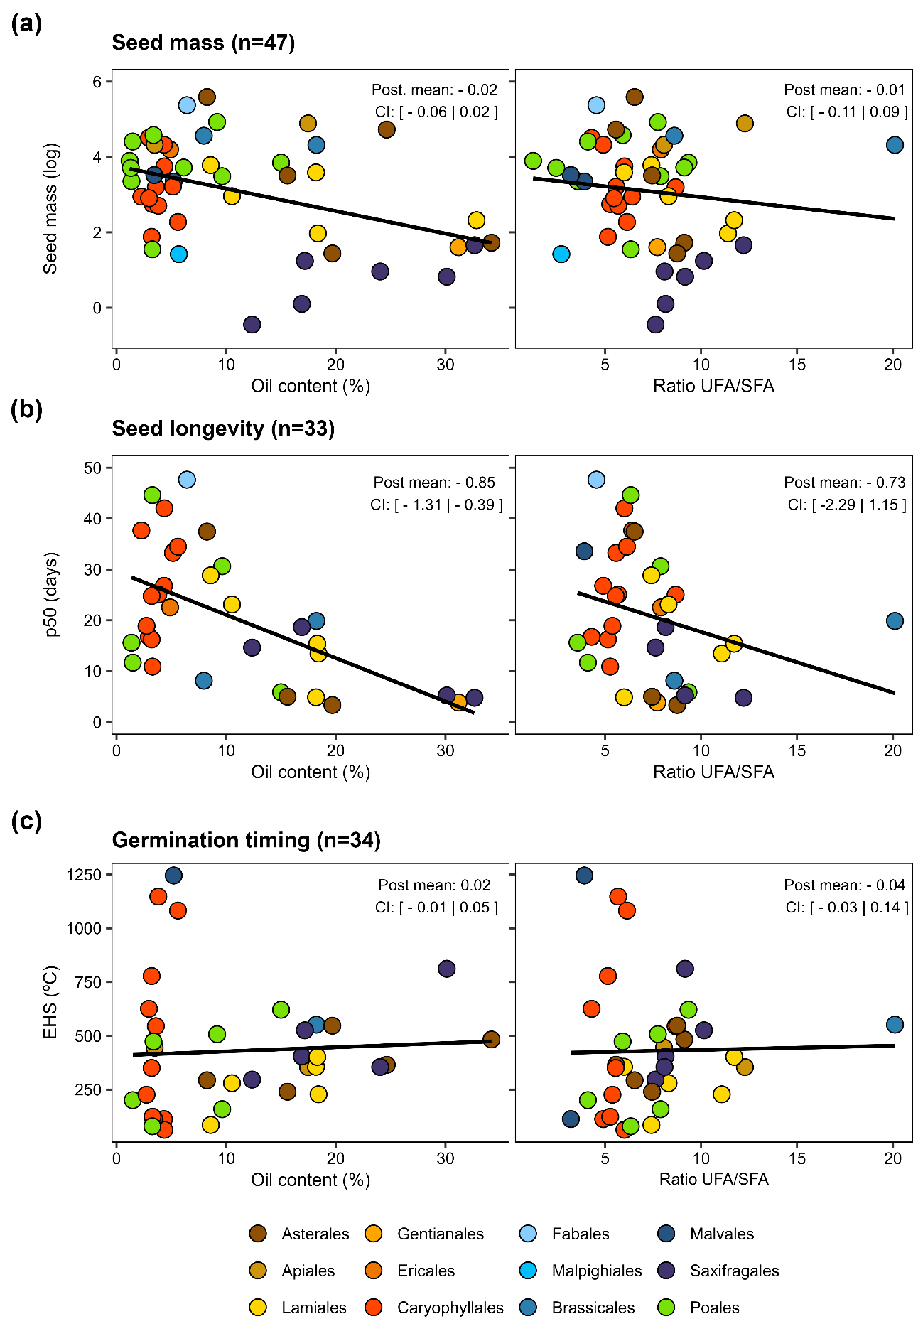

Figure 4. Relationships between seed oil content and UFA/SFA ratio with (**a**) seed mass, (**b**) seed longevity (p50) and (**c**) germination timing (EHS). All seed traits were measured for 47 alpine species of northwestern Spain in the laboratory. Significance values from MCMC-GLMM models (Gaussian family) showed by posterior mean (post. mean) and credible intervals (CI); if CI values do not overlap with 0, they indicate a significant relationship. Colours represent the different plant orders.

### Microclimatic drivers

GDD values ranged from 650 to 2295 °C, averaging 1421 °C (se = 67.9), while FDD values ranged from 0.05 to 170 °C, with a mean of 31.8 °C (se = 4.7). We found a general trend of species with lower oil content and a lower UFA/SFA ratio preferring warmer conditions (high GDD and low FDD) along local microclimatic gradients (Fig. **5**), although these effects were not significant. The trends were more consistent for GDD, since the effect of FDD was mainly driven by a few species with more extreme oil content and composition values. In addition, snow values ranged from 3 to 157 days, with an average of 62 days of snow per year. The data showed a trend where species that preferred snowier sites showed higher oil content and UFA/SFA ratios but with no significant effects. Details of the model results are shown in supplementary Table S4.

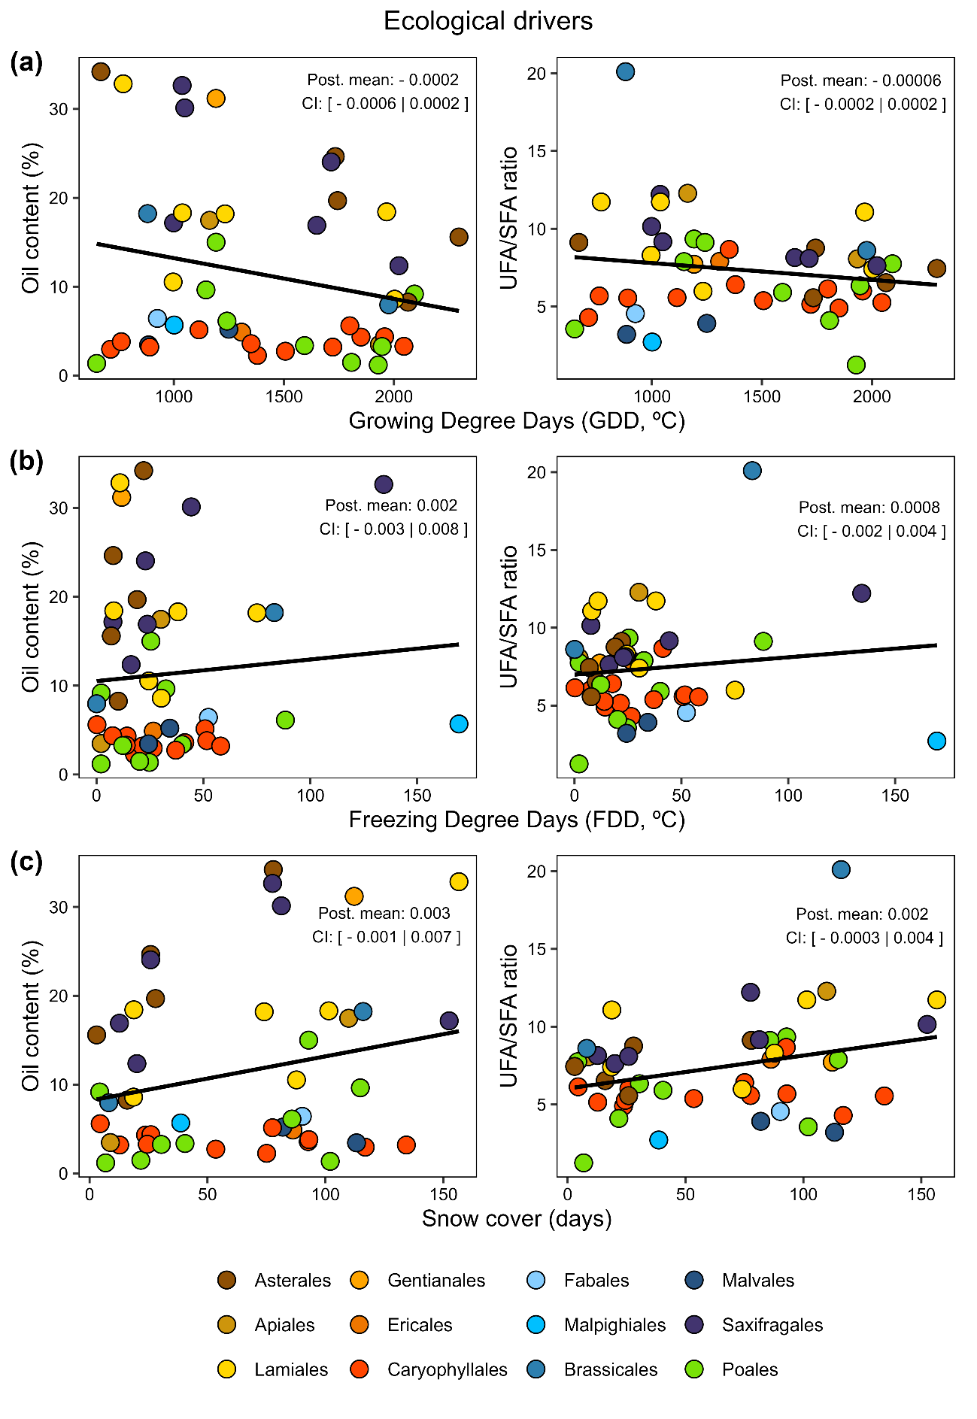

Figure 5. Seed oil content ecological trade-offs, oil content and ratio UFA/SFA log-transformed for MCMC-GLMM models (family=Gaussian, n=46), significances showed by posterior mean and credible intervals (CI); if CI values does not overlap with 0 indicate a significant relationship. (**a**) Relationship with GDD (Growing Degree Days °C); (**b**) Relationship with FDD (Freezing Degree Days °C) and (**c**) relationship with Snow days.

## 4. Discussion

This study aimed to analyse functional trade-offs and ecological drivers influencing seed oil traits in alpine ecosystems. We found strong indications that seed oil content significantly influences seed longevity. However, no relationships were detected between seed oil content or composition with seed mass and germination timing. Interestingly, we found no evidence of temperature-related climatic patterns pointing to macroevolutionary processes driving seed oil traits in a regional alpine flora or across local microclimatic gradients.

### 4.1 Seed oil traits characterization of alpine species

This is, to our known, the first study investigating the variation of seed oil traits in an alpine flora. While oil content is known to vary globally from 1% in *Musa paradisiaca* to 76% in *Chrysobalanus icaco* (Matthäus, 2012), our alpine species showed a reduced but still relevant range of seed oil percentages (1-34%). This variation is similar to the results of other studies focused on herbaceous plants, like the one exhibited by weed species in France (Bretagnolle *et al.*, 2016). Our results align with the general variation in seed oil reported for herbaceous species in the pioneer studies of Levin (1974). The seed oil composition found in our alpine species was also comparable to what Bretagnolle *et al.* (2016) reported for weed species, except for erucic acid (C22:1n9) in Brassicaceae. Previous reports from other commercial Brassicaceae species confirmed high proportions of elongated acyl chains from C20 to C24 in this family (Baud & Lepiniec, 2010). The high levels of erucic acid are surprising due to its “high” melting point (33.5°C) (Sanyal & Linder, 2013), which would hinder energy release; however, erucic acid has also been associated with lower seed predation (Jong *et al.*, 2016). The ratio between saturated and unsaturated fatty acids obtained in our study was comparable to the one reported for weeds for Bretagnolle *et al.* (2016) (6.8 vs 7.1 for alpine and weed species respectively). Moreover, in both studies the same families were identify for higher (Poaceae) and lower values of SFA (Brassicaceae).

We found no significant differences along the altitudinal gradient within the regional alpine dataset. In evolutionary terms, alpine species are physiologically adapted to colder environments, originated from a subset of families and it appears that oil content is highly preserved for each evolutionary line, independently of their altitudinal distribution. Previous research involving different populations of a few cultivars species also failed to detect a significant positive correlation between seed oil and elevation (Dierig *et al.*, 2006; Cai *et al.*, 2012). These results might indicate a low effect of elevation in seed oil content (Dierig *et al.*, 2006), although there are reports of a positive correlation between oil content and mean temperature (Piper & Boote, 1999). Parallelly, Cai *et al.* (2012) found a positive correlation between elevation and percentage of unsaturated fatty acids within a single species grown in a broad altitudinal range, possibly due to plasticity or differential physiological functioning. Nevertheless, due to the limited oil composition data available we were not able to test this idea with our regional dataset.

### 4.2 Functional trade-offs

Within our alpine system, we could not confirm the expected negative relationships between seed mass and seed oil content described in the literature (Nagel & Börner, 2010; Hamilton *et al.*, 2013; Bretagnolle *et al.*, 2016). A plausible explanation for this result is that most studies reporting significant relationships include different vegetation types and multiple comparisons among herbs, shrubs, and trees. In contrast, our study focused on similar life forms, mostly herbaceous hemicryptophytes and dwarf chamaephytes, where seed mass and other biological traits are expected to be more constant (Díaz *et al.*, 2016). Similar non-significant trends were reported in another study focused on trees (Finkelstein & Grubb, 2002), suggesting that life forms constrain global variation in seed oil content and seed mass. Nevertheless, more studies across different life forms and vegetation types are still necessary to confirm this idea. In our local alpine species pool, we also found a negative trend between seed mass and UFA/SFA ratio. However, this trend contradicts the expectation of small seeds storing more saturated fatty acids (Linder, 2000), i.e. lower ratio values. We found a considerable variation of oil content in small seeds, although such variation strongly decreases towards low oil values in large seeds, supporting the results reported by Bretagnolle *et al.* (2016). We found indications of a strong phylogenetic signal of seed oil content and oil composition, confirming previous results (Sanyal & Decocq, 2016), with species from the same family mostly grouped together and a strong phylogenetic signal of seed mass. Interestingly, with our regional dataset, we consistently found a strong phylogenetic signal of seed oil content but not of seed mass, suggesting that alpine species are filtered towards small seed mass independently of their phylogeny.

In concordance with our expectations, we found a significant negative relationship between seed longevity and seed oil content. Despite alpine seeds generally being short-lived, they also shown considerable interspecific variation in the time taken for viability to fall to 50% (i.e. p50 varied from 4.7 to 35.7 days in Mondoni et al., 2011 and from 3 to 47 days in the present study). Here we provide a mechanistic explanation for such differences in the rate at which seeds lose viability, showing a consistent and significant decrease in seed longevity with increasing oil content. The UFA/SFA ratio also showed a decreasing trend of longevity with more unsaturated fatty acids, although not significant. This finding supports the hypothesis that oily seeds have lower longevity (Nagel & Börner, 2010; Neto *et al.*, 2019) and that a higher proportion of unsaturated fatty acids could be associated with shorter longevity (Hoekstra, 2005; Probert *et al.*, 2009). Our results are consistent with previously described adverse effects observed in seed longevity, possibly due to lipid oxidation (Bailly *et al.*, 1998; Tammela *et al.*, 2003) and contrast with other studies reporting no relationship between seed longevity and oil content (Walters *et al.*, 2005; Probert *et al.*, 2009; Gardarin *et al.*, 2010). With the current biodiversity crisis, plant conservation is a global priority, especially *ex situ* conservation in seed banks. Having the necessary knowledge and appropriate methods to store and maintain seed viability in these facilities is vital. The results presented here suggest that, for alpine species, seed oil content can be an important factor to control for in seed banks, while for other species pools, it might not be the case (Probert *et al.*, 2009), thus the oil impact is context-dependent. Measuring seed oil content and composition is a destructive yet fast method that can be used to separate those alpine species with particularly low seed longevity, which can then be included in more frequent germination screenings and seed lot renewals.

Based on previous studies by Sanyal and Decocq (2016) and Linder (2000), we predicted that alpine species, adapted to live and germinate under colder temperatures, would show earlier germination with increasing oil content and an increasing UFA/SFA ratio. Surprisingly, the negative relationship between oil content and germination timing contradicted our initial expectations. The lack of patterns with oil content is not completely surprising in wild species, as has been reported in rainforest species in Australia (Hamilton *et al.*, 2013), whereas weeds (Gardarin *et al.*, 2011) and crops (Gu *et al.*, 2019; Cheng *et al.*, 2024) have shown positive correlations. Observing this contrasting pattern between wild and crop-related species (cultivars or weeds) stresses the importance of human selection of varieties or cultivars exhibiting high oil content and earlier germination (Gardarin *et al.*, 2011; Gu *et al.*, 2019). This artificial selection has encouraged a lot of research focused on increasing oil content (Miao *et al.*, 2020) or improving oil composition for nutritional purposes, even for the production of biofuels (Dierig *et al.*, 2006). Nevertheless, these data are unrepresentative of natural patterns in wild species and more research is needed to fill this knowledge gap. We also observed the opposite expected trend with species with higher unsaturated fatty acids germinating later against the results of Linder (2000). A plausible explanation could be that alpine species' physiological seed dormancy constraints (Schwienbacher *et al.*, 2011) drive germination patterns more strongly than oil content and composition.

### 4.3 Microclimatic gradients

We focused on species-level traits with the expectation that species with different ecological niches along microclimatic gradients were selected for oil content. None of the local microenvironmental gradients studied (GDD, FDD and snow) showed significant relationships with oil content or composition. However, all three gradients show a consistent trend with species living in preferentially colder places (low GDD, high GDD and higher snow days) tending to a higher oil content and a higher proportion of unsaturated fatty acids, which could potentially be consistent with the anti-freezing properties of unsaturated fatty acids (Linder, 2000). The lack of regional and local alpine patterns seems to limit Sanyal and Linder's claims (Linder, 2000; Sanyal & Linder, 2013; Sanyal & Decocq, 2016) of strong temperature selection at the macroevolutionary level, constraining seed oil patterns. Nonetheless, in the present study, we worked with a cold-adapted alpine flora, with different degrees of cold preference/tolerance. Life in cold-season regions may impose some constraints on seed oil properties, such as temperatures during seed maturation, and these constraints may be so tight that they leave little room for within-region variation. However, providing a more complete picture is difficult due to the limited information on oil content and fatty acid composition available for wild species (Levin, 1974), especially involving other habitats and biomes.

## 4. Conclusion

Our results add new insights to the seed ecological spectrum of alpine species, and are a step forward to comprehending seed trait ecology in line with the framework described by Saatkamp *et al.* (2019). Specifically, we addressed the understudied topic of seed oil traits and their and correlates and drivers in wild species. We found a strong trade-off between seed oil content and seed longevity in alpine species, with potential implications for alpine ecology and also for ex situ conservation focused on seed banking of threatened alpine species. However, this might be one of the few trade-offs linked to seed oil traits, which are strongly conserved in the phylogeny of herbaceous species. Similarly, ecological drivers appear to have a limited selective pressure on seed oil and composition along regional altitudinal and local microclimatic gradients. Nevertheless, collective and global efforts are necessary to complement the few data available for wild species in order to disentangle seed oil patterns across species and vegetation types.

**Figure legends**

Figure 1. (**a**) Fatty acid biochemical properties; (**b**) Altitudinal oil content and unsaturated UFA/SFA ratio (Unsaturated Fatty Acids /Saturated Fatty Acids) patterns expected in our study.

Figure 2. Seed oil content and composition in 47 alpine species from northwestern Spain. (**a**) Oil content (%) per species, colours representing orders as panel D. (**b**) Seed oil composition of fatty acids with more than 10% relative proportion on average across species. (**c**) Seed oil composition per species with fatty acids divided between Unsaturated Fatty Acids (UFA) and Saturated Fatty Acids (SFA). (**d**) PCA with species as points and (**e**) variables directions and contributions.

Figure 3. Regional oil content patterns (n=80 species). (**a**) Seed oil content (%) between regional altitudinal distribution showed by different colours. (**b**) Seed oil content (%) and seed mass (mg) non-significant relationship (from MCMC-GLMMs models with gaussian family) showed by posterior mean (post. mean) and credible intervals (CI); if CI values do not overlap with 0, they indicate a significant relationship.

Figure 4. Relationships between seed oil content and UFA/SFA ratio with (**a**) seed mass, (**b**) seed longevity (p50) and (**c**) germination timing (EHS). All seed traits were measured for 47 alpine species of northwestern Spain in the laboratory. Significance values from MCMC-GLMM models (Gaussian family) showed by posterior mean (post. mean) and credible intervals (CI); if CI values do not overlap with 0, they indicate a significant relationship. Colours represent the different plant orders.

Figure 5. Seed oil content ecological trade-offs, oil content and ratio UFA/SFA log-transformed for MCMC-GLMM models (family=Gaussian, n=46), significances showed by posterior mean and credible intervals (CI); if CI values does not overlap with 0 indicate a significant relationship. (**a**) Relationship with GDD (Growing Degree Days °C); (**b**) Relationship with FDD (Freezing Degree Days °C) and (**c**) relationship with Snow days.

## References

**Bailly C, Benamar A, Corbineau F, Come D**. **1998**. Free radical scavenging as affected by accelerated ageing and subsequent priming in sunflower seeds. *Physiologia Plantarum* **104**: 646–652.

**Baskin CC, Baskin JM**. **2014**. *Seeds. Ecology, Biogeography and Evolution of Dormancy and Germination*. San Diego, CA, USA: Academic Press.

**Baud S, Lepiniec L**. **2010**. Physiological and developmental regulation of seed oil production. *Progress in Lipid Research* **49**: 235–249.

**Bretagnolle F, Matejicek A, Gregoire S, Reboud X, Gaba S**. **2016**. Determination of fatty acids content, global antioxidant activity and energy value of weed seeds from agricultural fields in France. *Weed Research* **56**: 78–95.

**Bu H, Chen X, Xu X, Liu K, Jia P, Du G**. **2007**. Seed mass and germination in an alpine meadow on the eastern Tsinghai-Tibet plateau. *Plant Ecology* **191**: 127–149.

**De Cáceres M, Legendre P**. **2009**. Associations between species and groups of sites: indices and statistical inference. *Ecology* **90**: 3566–3574.

**Cai ZQ, Jiao DY, Tang SX, Dao XS, Lei YB, Cai CT**. **2012**. Leaf photosynthesis, growth, and seed chemicals of sacha inchi plants cultivated along an altitude gradient. *Crop Science* **52**: 1859–1867.

**Chazarra Bernabé A, Flórez García E, Peraza Sánchez B, Tohá Rebull T, Lorenzo Mariño B, Criado Pinto E, Moreno García JV, Romero Fresneda R, Botey Fullat R**. **2018**. Mapas climáticos de España (1981-2010). *Mapas climáticos de España (1981-2010) y ETo (1996-2016)*: 75.

**Cheng H, Cai S, Hao M, Cai Y, Wen Y, Huang W, Mei D, Hu Q**. **2024**. Targeted mutagenesis of BnTTG1 homologues generated yellow-seeded rapeseed with increased oil content and seed germination under abiotic stress. *Plant Physiology and Biochemistry* **206**: 108302.

**Choler P**. **2018**. Winter soil temperature dependence of alpine plant distribution: Implications for anticipating vegetation changes under a warming climate. *Perspectives in Plant Ecology, Evolution and Systematics* **30**: 6–15.

**Davies RM, Newton RJ, Hay FR, Probert RJ**. **2016**. 150-seed comparative longevity protocol -A reduced seed number screening method for identifying short-lived seed conservation collections. *Seed Science and Technology* **44**: 569–584.

**Davies R, Sacco A Di, Newton R**. **2015**. Germination testing: procedures and evaluation. *Millenium Seed Bank Partnership Kew*: 4.

**Díaz S, Kattge J, Cornelissen JHC, Wright IJ, Lavorel S, Dray S, Reu B, Kleyer M, Wirth C, Colin Prentice I, *et al.*** **2016**. The global spectrum of plant form and function. *Nature* **529**: 167–171.

**Dierig DA, Adam NR, Mackey BE, Dahlquist GH, Coffelt TA**. **2006**. Temperature and elevation effects on plant growth, development, and seed production of two Lesquerella species. *Industrial Crops and Products* **24**: 17–25.

**Ellis R**. **2006**. *The Encyclopedia of Seeds. Science technology and uses* (M Black, J Bewley, and P Halmer, Eds.). Wallingford, CABI: CABI International.

**Ellis R, Roberts E**. **1980**. Improved Equations for the Prediction of Seed Longevity. *Annals of Botany* **45**: 13–30.

**ENSCONET**. **2009**. *ENSCONET Seed Collecting Manual for Wild Species*.

**Espinosa del Alba C, Fernández-Pascual E, Jiménez-Alfaro B**. **2024**. Microclimatic variation regulates seed germination phenology in alpine plant communities. *Journal of Ecology*: 1–14.

**Fernández-Pascual E, Carta A, Mondoni A, Cavieres LA, Rosbakh S, Venn S, Satyanti A, Guja L, Briceño VF, Vandelook F, *et al.*** **2021**. The seed germination spectrum of alpine plants: a global meta-analysis. *New Phytologist* **229**: 3573–3586.

**Finkelstein S, Grubb PJ**. **2002**. Lipid concentration in the embryo–endosperm fraction of seeds of Australian tropical lowland rainforest trees: relevance to defence and dispersal. *Seed Science Research* **12**: 173–180.

**García-Gutiérrez T, Jiménez-Alfaro B, Fernández-Pascual E, Müller J V.** **2018**. Functional diversity and ecological requirements of alpine vegetation types in a biogeographical transition zone. *Phytocoenologia* **48**: 77–89.

**Gardarin A, Dürr C, Colbach N**. **2011**. Prediction of germination rates of weed species: Relationships between germination speed parameters and species traits. *Ecological Modelling* **222**: 626–636.

**Gardarin A, Dürr C, Mannino MR, Busset H, Colbach N**. **2010**. Seed mortality in the soil is related to seed coat thickness. *Seed Science Research* **20**: 243–256.

**González Le Barbier J, Roces-Díaz J V., Jiménez-Alfaro B**. **2025**. Timberline Patterns and Dynamics Depend on Forest Type , Regional Climate , and Topography in the Cantabrian Mountains (Spain). *Journal of Vegetation Science* **36**: 1–12.

**Graham IA**. **2008**. Seed storage oil mobilization. *Annual Review of Plant Biology* **59**: 115–142.

**Gu J, Hou D, Li Y, Chao H, Zhang K, Wang H, Xiang J, Raboanatahiry N, Wang B, Li M**. **2019**. Integration of proteomic and genomic approaches to dissect seed germination vigor in Brassica napus seeds differing in oil content. *BMC Plant Biology* **19**: 1–20.

**Hadfield JD**. **2010**. MCMCglmm: MCMC Methods for Multi-Response GLMMs in R. *Journal of Statistical Software* **33**: 1–22.

**Hamilton KN, Offord CA, Cuneo P, Deseo MA**. **2013**. A comparative study of seed morphology in relation to desiccation tolerance and other physiological responses in 71 Eastern Australian rainforest species. *Plant Species Biology* **28**: 51–62.

**Harman G, Mattick L**. **1976**. Association of lipid oxidation with seed ageing and death. *Nature* **260**: 323–324.

**Harwood JL**. **1980**. *Plant Acyl Lipids: Structure, Distribution, and Analysis*. ACADEMIC PRESS, INC.

**Hay F, Adams J, Manger K, Probert R**. **2008**. *The use of non-saturated lithium chloride solutions for experimental control of seed water content*.

**Hoekstra FA**. **2005**. Differential longevities in desiccated anhydrobiotic plant systems. *Integrative and Comparative Biology* **45**: 725–733.

**Jiménez-Alfaro B, Silveira F, Fidelis A, Poschold P, Commander L. 2016.** Seed germination traits can contribute better to plant community ecology. *Journal of Vegetation Science* **27**:637-645.

**Jiménez-Alfaro B, Fernandez-Pascual E, Espinosa del Alba C, Marcenó C**. **2024**. Spatiotemporal patterns of microclimatic buffering in relict alpine communities. *Journal of Vegetation* **35** e13242.

**Jin Y, Qian H**. **2019**. V.PhyloMaker: an R package that can generate very large phylogenies for vascular plants. *Ecography* **42**: 1353–1359.

**Jong TJ De, Goeverden S Van, Jacobs R, Rurenga K**. **2016**. Major effects of glucosinolates and minor effects of erucic acid on predation of Brassica seeds by mice. *Basic and Applied Ecology* **17**: 706–713.

**Keck F, Rimet F, Bouchez A, Franc A**. **2016**. phylosignal: an R package to measure, test, and explore the phylogenetic signal. *Ecology and Evolution* **6**: 2774–2780.

**Knothe G, Dunn RO**. **2009**. A Comprehensive Evaluation of the Melting Points of Fatty Acids and Esters Determined by Differential Scanning Calorimetry. *Journal of the American Oil Chemists’ Society* **86**: 843–856.

**Körner C**. **2021a**. The cold range limit of trees. *Trends in Ecology and Evolution* **36**: 979–989.

**Körner C**. **2021b**. *Alpine Plant Life* (Springer Nature Switzerland AG 2021, Ed.). Springer Cham.

**Lee MRF, Tweed JKS, Kim EJ, Scollan ND**. **2012**. Beef, chicken and lamb fatty acid analysis - a simplified direct bimethylation procedure using freeze-dried material. *Meat Science* **92**: 863–866.

**Lehninger A, Nelson D, Cox M**. **1993**. *Principles of Biochemistry*. New York: Worth Publishers.

**Levin DA**. **1974**. The oil content of seeds: an ecological perspective. **108**: 193–206.

**Li Y, Beisson F, Pollard M, Ohlrogge J**. **2006**. Oil content of Arabidopsis seeds: The influence of seed anatomy, light and plant-to-plant variation. *Phytochemistry* **67**: 904–915.

**Linder CR**. **2000**. Adaptive evolution of seed oils in plants: Accounting for the biogeographic distribution of saturated and unsaturated fatty acids in seed oils. *American Naturalist* **156**: 442–458.

**Matthäus B**. **2012**. The new database Seed Oil Fatty Acids (SOFA). *Lipid Technology* **24**: 230–234.

**Miao L, Yang S, Zhang K, He J, Wu C, Ren Y, Gai J, Li Y**. **2020**. Natural variation and selection in GmSWEET39 affect soybean seed oil content. *New Phytologist* **225**: 1651–1666.

**Mondoni A, Probert RJ, Rossi G, Vegini E, Hay FR**. **2011**. Seeds of alpine plants are short lived: Implications for long-term conservation. *Annals of Botany* **107**: 171–179.

**Nagel M, Börner A**. **2010**. The longevity of crop seeds stored under ambient conditions. *Seed Science Research* **20**: 1–12.

**Neto LGP, Sartori MMP, Toorop PE, Da Silva EAA**. **2019**. Seed longevity differs in Astronium fraxinifolium Schott from two geographic regions in Brazil. *Revista Brasileirade Ciencias Agrarias* **14**: 1–7.

**Nonogaki H, Bassel GW, Bewley JD**. **2010**. Germination-still a mystery. *Plant Science* **179**: 574–581.

**Paradis E, Schliep K**. **2019**. Ape 5.0: An environment for modern phylogenetics and evolutionary analyses in R. *Bioinformatics* **35**: 526–528.

**Piper EL, Boote KJ**. **1999**. Temperature and cultivar effects on soybean seed oil and protein concentrations. *Journal of the American Oil Chemists’ Society* **76**: 1233–1241.

**Pritchard HW, Dickie JB**. **2003**. Chapter 35 Predicting Seed Longevity: : 655–721.

**Probert RJ, Daws MI, Hay FR**. **2009**. Ecological correlates of ex situ seed longevity: A comparative study on 195 species. *Annals of Botany* **104**: 57–69.

**Rael LT, Thomas GW, Craun ML, Curtis CG, Bar-Or R, Bar-Or D**. **2004**. Lipid peroxidation and the thiobarbituric acid assay: Standardization of the assay when using saturated and unsaturated fatty acids. *Journal of Biochemistry and Molecular Biology* **37**: 749–752.

**Rahbek C, Borregaard MK, Antonelli A, Colwell RK, Holt BG, Nogues-Bravo D, Rasmussen CMØ, Richardson K, Rosing MT, Whittaker RJ, *et al.*** **2019**. Building mountain biodiversity: Geological and evolutionary processes. *Science* **365**: 1114–1119.

**Saatkamp A, Cochrane A, Commander L, Guja LK, Jimenez-Alfaro B, Larson J, Nicotra A, Poschlod P, Silveira FAO, Cross AT, *et al.*** **2019**. A research agenda for seed-trait functional ecology. *New Phytologist* **221**: 1764–1775.

**Sanyal A, Decocq G**. **2016**. Adaptive evolution of seed oil content in angiosperms: Accounting for the global patterns of seed oils. *BMC Evolutionary Biology* **16**: 1–13.

**Sanyal A, Linder CR**. **2013**. Plasticity and constraints on fatty acid composition in the phospholipids and triacylglycerols of Arabidopsis accessions grown at different temperatures. *BMC Plant Biology* **13**: 0–13.

**Sattler SE, Gilliland LU, Magallanes-lundback M, Pollard M, Dellapenna D**. **2004**. Vitamin E Is Essential for Seed Longevity and for Preventing Lipid Peroxidation during Germination. *The Plant Cell* **16**: 1419–1432.

**Scherrer D, Körner C**. **2011**. Topographically controlled thermal-habitat differentiation buffers alpine plant diversity against climate warming. *Journal of Biogeography* **38**: 406–416.

**Schwienbacher E, Navarro-Cano JA, Neuner G, Erschbamer B**. **2011**. Seed dormancy in alpine species. *Flora: Morphology, Distribution, Functional Ecology of Plants* **206**: 845–856.

**SER, INSR, RBGK**. **2023**. Seed Information Database (SID).

**Tammela P, Nygren M, Laakso I, Hopia A, Vuorela H, Hiltunen R**. **2003**. Volatile compound analysis of ageing Pinus sylvestris L. (Scots pine) seeds. *Flavour and Fragrance Journal* **18**: 290–295.

**Theodoulou FL, Eastmond PJ**. **2012**. Seed storage oil catabolism: A story of give and take. *Current Opinion in Plant Biology* **15**: 322–328.

**Voelker T, Kinney AJ**. **2001**. Variations in the Biosynthesis of Seed -Storage Lipids. *Annu. Rev. Plant Physiol. Plant Mol. Biol.* **52**: 335–361.

**Volk GM, Crane J, Caspersen AM, Hill LM, Gardner C, Walters C**. **2006**. Massive cellular disruption occurs during early imbibition of Cuphea seeds containing crystallized triacylglycerols. *Planta* **224**: 1415–1426.

**Walters C, Wheeler LM, Grotenhuis JM**. **2005**. Longevity of seeds stored in a genebank: species characteristics. *Seed Science Research* **15**: 1–20.

**Westoby M, Leishman M, Lord J**. **1996**. Comparative ecology of seed size and dispersal. *Philosophical Transactions of the Royal Society B: Biological Sciences* **351**: 1309–1318.

**Zhang Y, Chen W, Smith SL, Riseborough DW, Cihlar J**. **2005**. Soil temperature in Canada during the twentieth century: Complex responses to atmospheric climate change. *Journal of Geophysical Research D: Atmospheres* **110**: 1–15.